Name_________________________________________ Due Date: January 18th, 2019
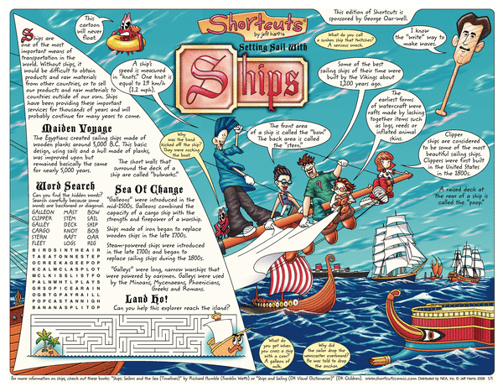
Short Cut Comics
Directions: You will complete a research based project on a nonfiction text that you have selected. You will create a shortcut comic as your final product. You will design your short cut comic on a large piece of construction paper.
Your “Shortcuts” must include the following:
____ (3pts.) An enlarged and creative title to describe the topic of your shortcuts.
____ (5 pts.) Include two real websites where your readers can go to learn more about your topic.
____ (10 pts) 10 or more fact “bubbles” each containing a different fact or piece of information about your topic. Write complete sentences inside each bubble.
____ (10 pts) You will need to include at least 4 elements used in cartoons (ie. Exaggeration, irony, analogy, symbolism, distortion)
____ (10 pts) Your research must include at least THREE sources. You must create a bibliography page to
cite these.
____ (7 pts) Use correct grammar and spelling.
____ (10 pts) You will need a Crossword Puzzle, using at least 12 important words relating to your
topic/person.
____ (10 pts) You need to include three multi-step math word problems using factual information regarding your topic. Your problems should be relevant to the topic/time period your person lived in.
____ (10 pts) You need to include at least three jokes, puns, or riddles.
____ (10 pts) You will need to include at least 5 neat colorful illustrations that pertain to your topic.
____ (10 pts) You need to create a 10 question test for students to take after reading your “shortcuts”. You can make it a true/false, multiple choice, or fill-in the blank assessment.
____ (5 pts) You will need to create a generalization about your topic/nonfiction person.

**You may include anything else additional to your shortcut comic i.e. additional illustrations, maze, word search, etc.**
_____________/100 Total Score

My Pacing Calendar
This must be completed each day at the beginning and end of Reader’s Workshop!
Remember, you will work on this at home instead of your Reading Homework Contract

Day | Work Completion Goal | What did I get done in class? | What do I need to take home in order to meet my goal?
Monday 1/14
Tuesday 1/15
Wednesday 1/16
Thursday 1/17
Friday 1/18 | Finish up last minute minor details, and use rubric to self-assess.

