5th Grade Character Project

CCSS: 5.RL.1, 5.RL.2, 5.RL.3, 5.RL.4
Directions: Read a fictional text of your choice and then complete the project requirements below. You must complete all Bloom’s Taxonomy activities as well as all the written response questions. You may choose to do it electronically or paper/pencil and displayed on a poster board. Choose one of the following as a way to visually display your project using technology: Google slides or Prezi. You must get teacher approval for any other options.
Project Requirements:
Remember | Understand | Apply | Analyze | Evaluate | Create
While reading your text, keep track of unfamiliar/ unknown words. Complete a vocabulary web for 2 of those words. 5.RL.4  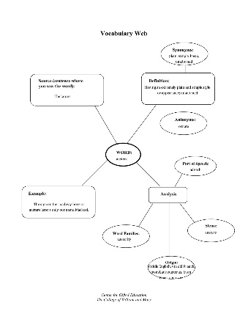 | Summarize your novel by giving the gist (no more than 5-7 sentences) then identify 3 conflicts throughout the story. Tell what type of conflict they are and how the conflicts were resolved. 5.RL.2  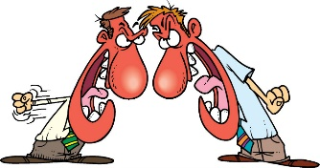 | Complete a double bubble thinking map to compare and contrast the 2 characters you chose. 5.RL.3  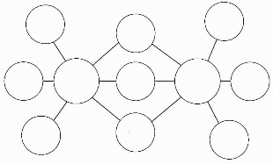 | Choose 2 main characters from the book and create a character analysis diagram for each.5.RL.3  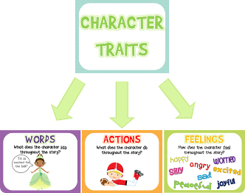 | Complete a literature web. For each part of the literature web you must provide 3 pieces of text evidence to support your thinking. If you complete on paper write your text evidence on post-it notes placed on top of your literature web. 5.RL.1, 5.RL.2  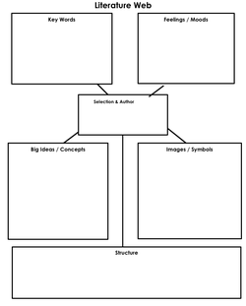 | Design the character’s room. Watch the following video first: (https://www.ted.com/talks/sam_  martin_builds_a_room_of_his_own)  Each item you place in the room should reveal something about the character. Consider their change over time. Design this room on paper, create a diorama, or build the room in Google Sketchup.
Written Response Questions:
- Theme is the underlying message of a story. Identify the theme of your novel. Think about how the author tried to make readers understand the theme. Explain how the theme is developed throughout the novel. Include 3 examples or quotes from the text where the theme is present. 5.RL.2
- Create a playlist of three songs showing a character’s growth during the story. Explain how these songs show the character’s change over time. 5.RL.3
- Which character’s point of view is used to tell the story? Why do you think the author chose this character to be the narrator? Tell one event from the story from a different character’s point of view. What evidence from the text helped decide how to change the description of the event? 5.RL.3
- Explain how the setting of the novel influenced the events, characters actions, and decisions. 5.RL.3
5th Grade Reading Project Rubric
Criteria | Total Points Possible | Points Earned
Remember –  Vocabulary web is completed for 2 unknown words throughout the novel. The student chose words that are challenging to him/her and helped them with their vocabulary. All components of the web are complete (1 point for each web) | 2
Understand –  Summary shows a thorough understanding of the book and between 5 to 7 sentences. (2 points)  3 conflicts were identified and there is an explanation as to how they were resolved. (1 point for each conflict identified and 1 point for each explanation as to how it was resolved). | 8
Apply -  Double bubble map is complete and thoroughly compares and contrasts two of the main characters from the book. The bubble maps show that the student has an exceptional understanding of the character. There are at least 5 similarities and 5 differences. Each similarity and difference contains text evidence from the book. (1 points for each similarity with accompanied text evidence and 1 point for each difference with accompanied text evidence. If non text evidence is given, the point is not earned). | 10
Analyze -  Character analysis diagram is complete and detailed for 2 of the characters in the book. (1 point for each box on the diagram for each character) | 12
Evaluate -  Literature web is complete and detailed. Each box has at least 3 ideas written down accompanied by 3 pieces of text evidence. The structure box only needs an explanation as to how the book is organized. Breakdown of points:  Key Words = 1 point for each of the 3 key words and 2 points total for the three pieces of text evidence = 5 points  Feelings = 1 point for each of the 3 feelings and 2 points total for the three pieces of text evidence = 5 points  Big Ideas = 1 point for each of the 3 big ideas and 2 points total for the three pieces of text evidence = 5 points  Pictures/Symbols = 1 point for each of the 3 pictures/symbols and 2 points total for the three pieces of text evidence = 5 points  Structure = 1 point for an explanation | 21
Create -  Character’s room is detailed, neat, and complete. There are at least 10 items in the room that represent something about that character. The items are listed and an explanation of each item is explained in writing. (1 point for each item listed and explained and 12 points for the creative/colorful design of the room either digitally or on paper) | 22
Written Responses -  Question #1 – 4 points (One point for a correctly identified theme and 3 points for the 3 detailed examples)  Question #2 – 9 points (3 points for the 3 songs and 2 points for each song for the detailed explanation)  Question #3 – 8 points (2 points for each of the questions)  Question #4 – 3 points (1 point for explaining how the setting influenced the events, 1 point for explaining how the setting influenced character actions, 1 point for explaining how the setting influenced the character’s decisions) | 25
WOW Factor – Student consistently went above and beyond for each part of the project. | 5
Total Points: ______ / 100 + 5 bonus point = 105 Final Grade: ___________ /100%

